# C27 TGP1 UN/Welcome GDD

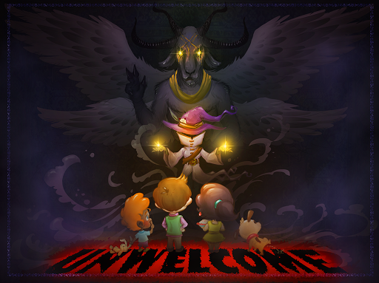

# Concept

### 

## Loops and Pillars

### Gameplay Loops[1]

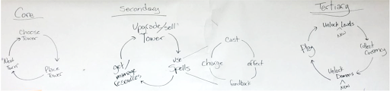

Core Loop - per turn: Choose Tower -> Place Tower -> hit "Next Turn" button

Secondary Loop - level: Consider Strategy -> Sell towers -> Place new towers -> get/manage resources

Tertiary Loop - Game: Unlock new levels -> play

### Pillars[1]

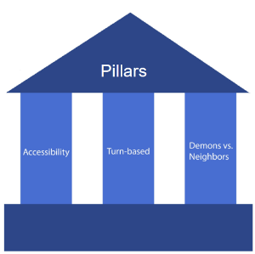

Pillars: 1. Accessibility The player shouldn’t feel overwhelmed or frustrated playing the game. Mechanics should be easy to pick up and fun to play with, and the art style of the game shouldn’t be upsetting or graphic.

1. Turn-based Meaningful actions by the player should be centered around the turn based structure. The player should be able to predict what will happen in the next turn and make decisions around that.
2. Demons vs. Neighbors The gameplay and art should make a distinction between the witch’s ‘side’ (magic, demons, summoning) and the neighbor’s ‘side’ (annoyingly friendly, colorful, intrusive).

## Game Description

#### Game goals and Features

(Two or three paragraphs describing the game)

UNWelcome is a turn-based tower defense game with many puzzle elements. In UNWelcome, you play as a suburban witch who is overwhelmed by her overly friendly neighbors. The player's goal is to kick neighbors out of the witch's house by summoning demons, which move neighbors around the space in different ways. Players must strategically place demons to push, pull and spring neighbors out of the house before they reach the witch. In UNWelcome, players can summon any number demons using their energy.

There are three different demons available to the player : Baphomet, who pushes neighbors in a straight line, Maalik, who springs neighbors over small obstacles like desks or couches, and Tamamanomae, who attracts neighbors to the tile she is summoned on. The range of functionality gives players the freedom to find a number of solutions for any given level, and experiment with different demon combinations.

#### Context

(Story, setting, player motivation - one or two short paragraphs describing the plot of the game, this is NOT backstory, but the story the player experiences as they play)

In UNWelcome, the player plays as an introverted witch, who has moved to suburbia. Overly friendly neighbors keep coming into her house uninvited, and to find some peace and quiet, she must kick them out. She summons demons around the house to forcibly remove the neighbors, but summoning demons drains her energy. If the neighbors reach her, the witch will have to interact with them, which will also drain her energy. The witch aims to kick all of her intruding neighbors out of her house, and enjoy some time to herself.

#### Style and Tone

(Write one paragraph describing the look and feel of the game)

## Player Skill Flow Chart

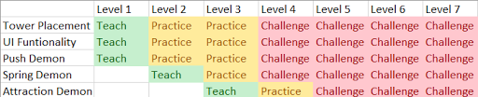

# Gameplay

## Key Game Features

### Neighbors

Neighbors come into the house in waves, and make their way through the house towards the witch. If they reach the witch, the player will lose energy. If the player runs out of energy (health), they lose the level and must retry in order to continue playing.

Neighbors can be moved around the house by demons. If they are pushed onto an exit tile (a window, the front door, a drain, etc.) , they are kicked out of the house for good. Neighbors cannot be moved through obstacles but can be moved over them.

Neighbors can be affected by other demons while still being moved by the first demon. For example, if a neighbor is pushed by a push demon, they will move 5 blocks. However, if at the third block there is a spring demon, the spring demon's effect takes over once the neighbor reaches it (while the neighbor is still being moved by the push demon), and the push demons effect will have stopped. The spring demon then throws the neighbor.

Neighbors have predictable movements and don't vary too much. Players can view neighbors movement range by either long pressing on the neighbor icon or switching on the range indicator toggle on the top left of the side panel.

#### Mechanics

All neighbors move in the same way. Neighbors move 3 tiles per turn and will find a new path to the witch if they are thrown off the main path. If a neighbor is affected by a demon, their turn will end and they will not move after the demon's affect is finished.

#### Feedback - Path

Neighbor's main path from entrance to the witch will be displayed as a different tile than the rest of the house. Could be a different material, indicated with light, etc.

When a neighbor gets pushed off the main path, they calculate a new path back to the main path. This temporary path will be shown with temporary footprint sprites on each tile, which disappear once the tile has been traversed by the neighbor.

#### Feedback - Movement

Feedback while the enemy is moving will be largely handled on a per turret basis. Look to the demon section.

### Demons

Demons are summoned by the player at in between turns, and are used to move neighbors out of the house. Each demon has a unique effect. When the player places a demon they should be thinking "This is the correct piece I need to complete my setup" not "Well, I'll pick this demon because it can do the job." There should a clear feeling of "This decision I am making is important to my overall plan and goal."

Each demon has a cooldown for its effects. This cooldown recharges by 1 every time the enemies make a movement. (Enemies moving 1 tile = 1 movement). Enemies being moved by demons does not affect the demon cooldown. This cooldown will be described as "steps" - if a demon has a cooldown of 3 steps, the demon will recharge once enemies have moved through 3 tiles.

Neighbors do not collide with demons. The neighbors can walk through the demons.

Level designers are able to pre-place demons in levels to teach players about demon functionality.

Player can sell the demon and regain energy by tapping on the demon and then tapping on the sell button.

Player can adjust the demon's direction by tapping on the demon and then tapping rotate button.

#### Push Demon

Pushes neighbors in a straight line up to a maximum distance of 5 tiles in the direction it is facing. Cannot push neighbors through obstacles, but can push them very far across open terrain.

Range: 5 (enemies are pushed 5 blocks. They stop if they hit an obstacle, and are removed if they hit an exit) Activation Range: The tile it is placed on and 1 tile in front of it (in the direction it is facing) Cooldown: 3 steps

##### Range Indicator

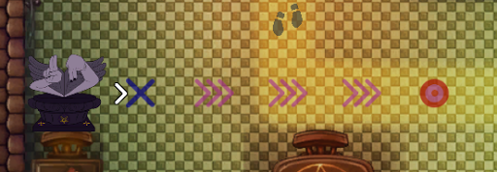

#### Spring Demon

Throws neighbors in the direction it is facing, completely over a single tile. Can be used to throw neighbors over obstacles. Spring towers can only launch over obstacles 1 tile long. Anything >1 long as an obstacle, the enemy will be dropped on the side the turret is on.

Range: 3 (the activation tile is counted as part of the range.) The 3rd tile (the landing tile) is the only one the thrown enemy contacts with. The enemy can be thrown over obstacles. Enemies can still be affected by other demons while being thrown, and will still exit if they are thrown "over" an exit tile. Activation range: The tile it is placed on and 1 tile in front of it (in the direction it is facing) Cooldown: 3 steps

##### Range Indicator

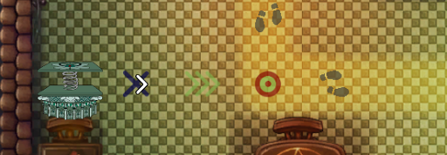

#### Attraction Demon

Pulls neighbors within a range towards it. When the neighbor reaches this demon, it will realize it has been charmed and continue moving towards the witch. All enemies in range are pulled when the tower activates.

Range: 4 (Enemies are pulled until they are on top of the demon and then stop.) Activation Range: 4 (The activation range is a line in front of the demon) Cooldown: 6 steps

##### Range Indicator

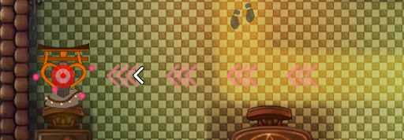

### Feedback - Firing/Range/Animations

Demons use colored X's to denote their activation range. X's are placed on the demons activation tiles. There is also a bullseye mark denoting the final tile that the neighbor will be moved to. Chevrons point from the activation tiles to the target tile, to denote every tile the neighbors will pass through. Pull demons activate on every tile marked with a chevron.

These range indicators are only present while the player taps and holds on top of the demon, or when the player has turned on the "Show all indicators" button on the side panel.

Push demon Feedback - Arrow particles, demon animation

Spring demon feedback - the neighbor is increased in size while thrown, and goes back to normal size when the throw is over, demon animation

Attraction demon feedback - The demon glows pink when firing. Neighbors have bright pink hearts popping up around them while they're being moved.

### Gameplay basics

Neighbors cannot move through obstacles (walking, pushed, pulled), but they can be moved over obstacles (spring).

Neighbors find a path to the witch and the player loses energy if the neighbor reaches the witch. Energy is spent to summon demons. Neighbors can walk through demons.

Demons have specified activation tiles and a specified range. The demon only activates if the neighbor passes over the activation tile(s). Each demon's activation tiles are described in the section for the individual demons.

Each level is played in a wave mode. If the player completes all the waves they have beaten the level.

Each neighbor removed increases the player's score value and returns health to the player.

#### Intended gameplay style

We want players to be creating solutions in the level, and then replaying the level to see if they can make a better solution than their previous attempt(s). Players should be enabled to easily edit their solutions to the levels.

#### Neighbor paths

Neighbor paths are denoted to the player in two ways.

The main path (from the front doors to the witch) are lighter than surrounding tiles, and are always visible to the player.

The temporary paths neighbors use to get back to the main path are have a light pink overlay. These temporary paths are only visible while the enemy is moving back to the main path. The temporary path overlay disappears once the neighbor walks through the tile.

#### Turn System

UNWelcome uses a turn system in its gameplay. Enemies can only move and be affected during the enemy's turn, and players can only summon demons during the player's turn. The turn only advances once the player pushes the next turn button.

### Resources

There is one resource in the game: the player's health (referred to as energy).

Players spend energy to summon demons, and can regain energy by moving enemies to the indicated locations. (The removal locations: windows, chimneys, and trapdoors)

### Conveyance

#### Demons

Demons convey their states using color change, sounds, and particles.

When firing each demon creates a sound effect and spawns a particle system. This signals to the player that the demon has activated.

After activating, the demon and its directional indicator are overlayed with a gray color The demon also has a small circle next to it to show its cooldown, which only appears while the demon is recharging. Each step the neighbors take reduces the pie chart until it is gone. When the pie chart is gone the demon is ready to fire, and it will return to its original color. The demons targeting range can be viewed by the player by pressing and holding on the demon. This shows the player the demon's possible range. Chevrons appear to indicate direction, and a target appears to indicate where the neighbor will be pushed to. These icons can also be displayed by turning on the "toggle all indicators" button.

Demons use a different color palette than neighbors (darker colors rather than brighter ones.) Each demon's color palette is unique, and the small icons correspond to the larger images that are shown on the right of the screen in the HUD.

#### Neighbors

Neighbors use very bright, pastel colors to stand out from the background and the demons.

When neighbors are being moved they are affected in different ways depending on which demon triggers on them: If the neighbor is pushed or thrown into an obstacle, a small cloud of arrows appears in the direction the enemy is moving. If a neighbor is being thrown, they will become larger while being thrown, to help convey that the neighbors are being thrown over obstacles. While being pulled, a small particle system spawning hearts will signify that the neighbor is being attracted to the pull demon.

#### Health/Resource

The player's energy is used as a resource for building turrets. When energy is spent on a demon a small red number with a minus sign appears above the player's energy bar. When energy is gained by removing enemies, small green numbers with a plus sign appear above the player's energy bar to signify energy gained. The player's energy bar is then updated. These numbers fade out over their lifetime.

#### Exits

Exits are conveyed to the player by using the color yellow and animation. The bright colors of the exit locations contrast with the dark tones of the environment which cause the exits to stand out. Small idle animations for each exit type draw the player's attention to these tiles.

### Menu Icons

Symbols are used to communicate what each menu icon does.

A gear for settings. A Forward facing arrow for next turn. A Magnifying glass with a indicator chevron for toggling all indicators on and off. A heart in a jar of green liquid shows the player's health. The jar empties as the player loses health.

[CUT] A double arrow for auto-playing turns.

### Gameplay Minute

(The storyboard and narration describing the average player experience) After loading into a level, the player looks at the layout of the level, and places demons around the house in a configuration that they think will be effective. The player might turn on range indicators, or click and hold on specific demons, if they want to be certain that their configuration will work as expected. The player will hit the next turn button to watch their plan in action. Neighbors will be affected by the demons, and some will be kicked out of the house, thanks to the player's strategy. When the turn ends, the player will evaluate their configuration, and might choose to place more demons or reposition some demons to deal with more of the oncoming neighbors. As their configuration of demons becomes more effective, the player might spend less time planning between turns, and will progress through the remainder of the level more quickly. When there are no more incoming neighbors, the player wins the level.

#### Video

Link to the gameplay video: <https://youtu.be/HbjIcK5Bskw>

# World Layout

## Tutorials

### Tutorial 1 Flow

Tutorial 1 teaches the player about: Push demon mechanic Summoning Demons Viewing Demon ranges Viewing the neighbor's path

### Tutorial 2 Flow

Tutorial 2 Teaches the player about: Spring demon mechanic Neighbors could be pushed away from the main path Summoning demons on obstacles and off obstacles Comboing the demons

### Tutorial 3 Flow

Tutorial 3 is similar to the "normal" levels, except a text tutorial explaining the mechanic of the attraction demon. There is also a pre-placed attraction demon in the level to show how it works.

# Production

## Risks

### Production

We might be short of hand if any of the team members are sick or injured. Especially the artist and the programmer since no one else in the team could replace their roles.

We might have scope issues since the time and efforts of the team are affected by each individual's other school work. Since we are not sure about each member's schedule there could be a situation that some of the team members need to work more on their own projects instead of the team project.

### Game Design

The biggest risk of game design is whether the game designers could balance the in-game resources well to provide challenging and interesting gameplay. The game experience would suffer if the balance is poorly down and the player will feel the game either too easy or too hard and abandon the game.

Another risk of game design is whether the level designers could create enough fun levels to support the gameplay. We won't have a lot of time to iteratively playtest so finding the fun in prototype levels can be challenging.

### Technology

The biggest risk in technology is the lack of experience. Only one of the 4 team members has the experience in developing games on Android platform. There could be unknown risks that the team could not foresee to avoid.

Another risk in technology is the performance issue. Since there will be multiple levels in our game. It is possible that the game could crash if it loads too many scenes and assets at a time. The team needs to do more tests to understand the limits of the device.

### Art

The biggest risk in Art is the scope of work. In our game, there is great demand for art assets and the demand would increase as the development proceeds.

Another risk is the workload for the animation. We only did a simple testing on the mechanics of the animation but not a full test to cover all the possible usage of the animation in our game. It's difficult to estimate the workload for all the animation at this stage.

Demons will be represented by small icons, neighbors will be represented by a top down view of the neighbor. When either is clicked on, a pop up to the side will show the "fancy" art version of the selected item as well as the item's info. (Icon VS character)

## Target Audience

## Target Individual [2]



Is a freshman and goes to a college in a city far from his home. Takes a bus or train to school every day, he enjoys playing games during commuting. Loves to play strategy and puzzle games, but he only has fragmented time for playing due to his heavy work. Prefers relaxing and funny games, he plays most of his games on mobile devices. Familiar with slang and meme.

## Target Demographic

Age: 16 - 30 Groups: Students, Young Adults, Casual Players Genre Preferences: Puzzle, Tower Defence, Adventure, Role-playing Install Base: Android Devices (Android version 4.3+)

### Player Type

Our game appeals to Rational/Explorer type players. The core experience of the game is exploring mechanics to find solutions to the problem in front of the player.

The game also appeals to Achiever players who enjoy creating better solutions than what others (or themselves) have created in the past.

#### Explorer

#### Achiever

### ESRB Rating

#### T for Teens

### Trello Link

Link: <https://trello.com/b/yUTy4Fhw/bleb-unwelcome> If you need the permission to comment, please let the team know.

### SCM Link

Link for editing: <https://docs.google.com/spreadsheets/d/1RDju_4Vl_9yPNaSJyW2kIOO46sk_jwvWvuESzL0hURE/edit?usp=sharing>

# Art

## ART DESIGN CATALOG PDF

### Environment

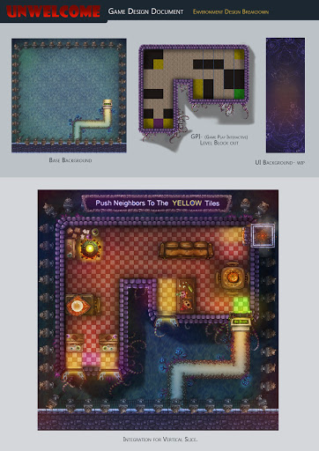

Environment is composed of tile sets that can be changed around to make each level look different from the next. Certain objects will be consistent throughout (torches, rugs, windows, etc.) There are wood floor tiles and ceramic tiled floors.

Different pieces of furniture will be made to correspond with the type of obstacles found in specific rooms. The obstacles are static and do not animate. They use a similarly dark color scheme as the demons and the environment. Examples include: Tables Chairs Armchairs Sofas Shelves Desks

Exits are bright pieces of the environment. They use a brighter color scheme to correspond with the neighbors. Exits are animated to bring the players attention to them. Examples include: Windows Bay windows Doors Chimneys Trapdoors

***WALLS ARE CUT*** (Walls are placed to delineate rooms to the player. These walls are static and neighbors cannot be moved through them at all. Walls are shown with a black bar that has molding around the edges of it. Assets like paintings and torches are placed on walls to help convey to the player that it is indeed a wall. Walls can also be shown by running wires through them, or placing cobwebs and skeletons inside them.)

#### Design Datalog for Art

<https://drive.google.com/file/d/0B4_csB2vev-uMXZGQmhVM0hDZHc/view?usp=sharing>

### Character Concept

#### Neighbors [1]

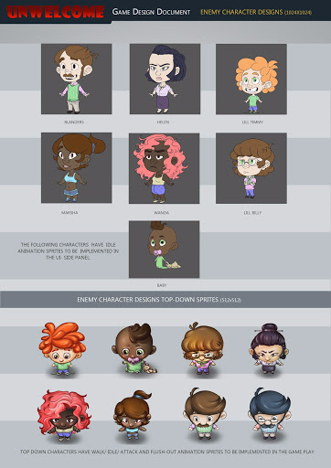

Icon Anims (256X256) ----- Character Anims (1024X1024) Move (4 frames) ----- Idle (8 frames) *** Move: walk;thrown;pushed;attracted Idle (4 frames) ----- Hit (4 frames) Attack (4 frames) ------ Attack (8 frames) "Death" (4 frames) ------- ?"Death" (4 frames)/?Move (4 frames)

#### Demons

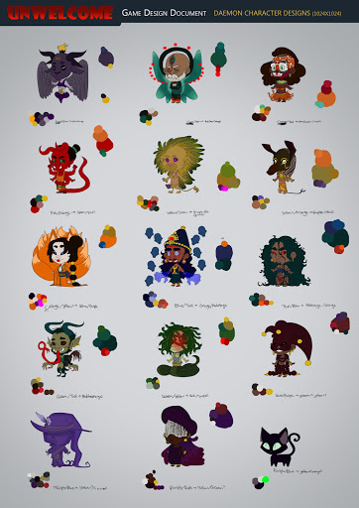

Icon Anims (256X256) ----- Character Anims (1024X1024) Idle (4 frames) ----- Idle (?8frames) Attack (4 frames) ----- Attack (?8frames) ?Replenish (4 frames) ----- ?Replenish (?8frames?)

* [1]

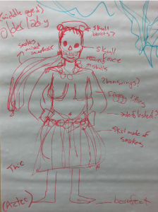

* [1]

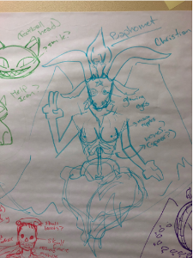

* [1]

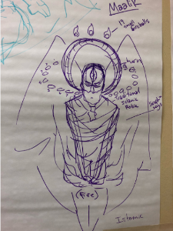

#### Witch

Icon Anims (256X256) ----- Character Anims (1024X1024) Idle (4 frames) ----- Idle(8 frames) Hit (4 frames) ----- Hit (4 frames) Death (4 frames) ---- Death (4 frames) ?Replenish? (4 frames) ---- ?Replenish? (8 frames) ?Summoning (4 frames) ----- ?Summoning? (8 frames) ?cheer animation (4 frames) -------- ? cheering animation -- when enemy death (8 frames)

* Cat
* Icon Anims (256X256) ------ Character Anims (1024X1024) Idle (4 frames) ---- Idle (4 frames) ?Replenish (4 frames) ----- ?Replenish (4 frames) ?Attack (4 frames) -------- ?Attack (4 frames)

### Summoning animation

The summoning animation is played when a demon is summoned in the playing area. The big head art that corresponds to the demon summoned appears on the side of the screen while the player is selecting the demon and rotation. Once the rotation has been selected the big head moves towards the top of the active area of the side panel while shrinking. The demon icon then grows on the playing field and the big head grows back in on the side panel. The animation is then over and the demon is ready to fire.

### UI Framework

Link to the UI framework: <http://3ggcm9.axshare.com> PSW: bleb

When placing demons, a small icon for each demon is placed next to the text outlining its functino. (Push, pull, or spring.) These small icons correspond to each demon specifically to give the player a visual connection for each demon and its function and button.

#### UI Interactions

##### Range Indicators

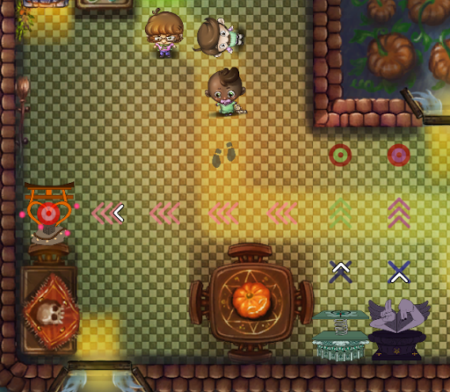

Players can show range indicators by tapping the magnifying glass on the side panel or tapping and holding on individual demons or neighbors.

Blue 'X' - Shows what tiles the demon activates on, with the exception of the attraction demon. (The attraction demon activates on the chevrons)

Chevrons - These show what tiles the neighbor will be moved across

Bullseye - This shows where the neighbor will come to rest. The bullseye is slightly colored according to whichever demon type it is associated with. (Purple for push, green for spring, and pink for attraction)

Whichever demon was placed last draws its range indicators over the indicators of the other demons. The demons range indicators will stop at the end of their range. For example, a push demon has 5 total range. If there is a wall 3 tiles from the push demon its range indicator will only show 3 tiles instead of the total 5. This is visible in the image. A push demon's total possible range is 5 but there are only 3 valid tiles in front of it.

Footsteps - These indicate where the neighbors will move along on the next turn. The demon targeting indicators draw over the neighbors' movement indicators. These are drawn below the demon range indicators.

##### Demon Placement - Selection

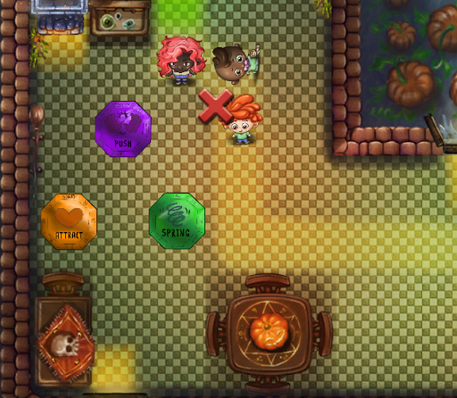

In order to place a demon players will: 1. Tap the tile they want to place a demon on 2. A popup will appear around that tile giving the player the option of building any of the 3 demons (Push, Spring, or Attract). 3. Players will tap which demon they want to place 4. Another pop up will appear showing some arrows. These arrows determine which direction the demon faces. Players will tap the arrow corresponding to whichever direction the demon should face. 5. The summoning animation plays 6. The demon is now ready to fire.

* Demon Placement - Rotation

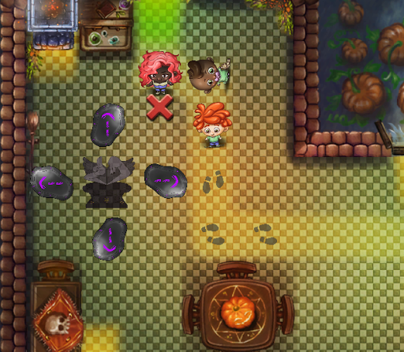

##### Interacting with demons

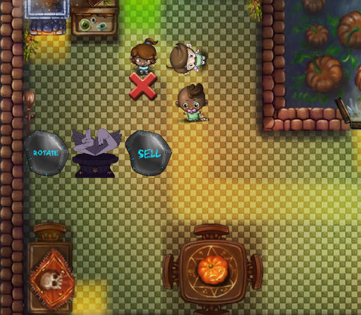

Players interact with existing demons by tapping on them. After the player taps on the demon a popup menu appears around the demon. This menu contains two options, rotate and sell. Rotate will allow the player to change the rotation of the demon and uses the same step as summoning the demon. Sell will return 75% of the energy cost used to summon the demon to the player and removes the demon.

* Basic Rotation

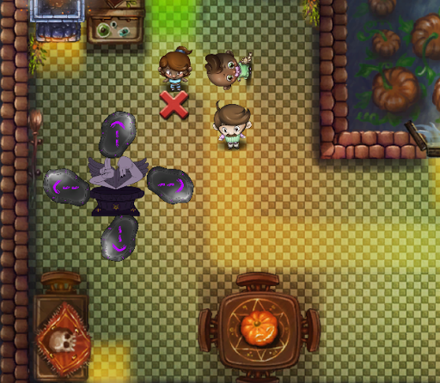

* + Attraction Rotation

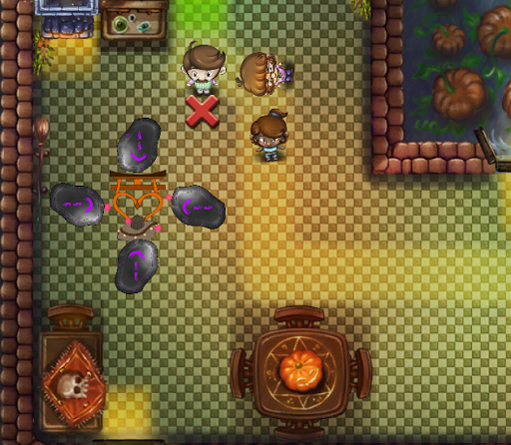

* + The arrows for the attraction demon are reversed from the other demons because the attraction demon moves the neighbors toward itself, and not away from itself.

#### General UI Info

A sidebar is present on the game at all times. This sidebar holds meta information about the game and menus. Final, larger character art is present here. Players can tap on specific enemies, or demons and receive more information about what was tapped on in the sidebar. (Demon cooldown, neighbor stats, demon characteristics).

Options, indicator toggle, and next turn buttons are present here as well.

Inside the options menu, the player can restart the current level, or return to the main menu,

The indicator toggle will turn all indicators for demon ranges/neighbor movements on or off.

The next turn button will begin the next turn when pressed.

##### HUD & Camera

The game uses a top-down view camera to show the full scale of the level. Players can use fingers to zoom in and out and can swipe to pan the camera.

HUD elements in the game: Health Bar: show the remaining health the player has. This is displayed as a glass bottle with a heart inside of it, filled with liquid. The more health the player has, the more full the full the bottle is.

Wave Number: Shows the remaining waves of neighbors in the level.

Score: show how many scores the player has gained. Score is gained by pushing neighbors onto exit tiles.

Pop-up art section: If the player taps on a demon or neighbor a larger picture of the tapped thing will show up in the sidebar. This larger view shows more detailed art and animations than the smaller versions on the playing field. Information about the demon/neighbor will also be displayed in the text area. Art still appears in the tutorial level, but the corresponding text is not displayed, due to the text area being used for tutorial text. Tapping on an empty tile will remove the art in a non-tutorial level.

Text Area: This area is used for tutorial text, and for displaying information about a demon or neighbor when the player clicks on it (on non-tutorial levels only). Tapping on an empty tile will remove text in a non-tutorial level.

* Side Panel

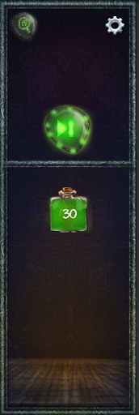

* The side panel is the location that holds all relevant meta data for players such as: Demon description Demon's attatch range Demon's cost of energy for summoning Player Energy Buttons (Next turn, range indicator, settings) Character art
  + Side Panel - Filled

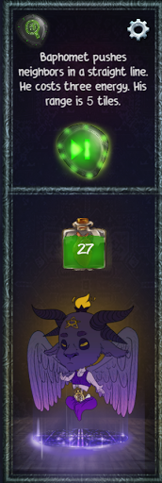

##### Controls

Players tap on the tiles to set up and manage the demons, tap on the demon icons to interact. Players tap the next button on the side panel to proceed the game Players tap on the indicator button to show all the demons attack range as well as the neighbors movement range, tap again to switch them off. Players use two fingers to zoom in and out to change the camera distance, use one finger to swipe to explore other areas in the level.

[CUT] Players can drag the spell icons from the sidebar and drop the icons to the tiles to cast spells.

# References

## internal

[1] By Team

## External

[2] [http://www.skepticblog.org/wp-content/uploads/sc00041f13.jpg](http://www.skepticblog.org/wp-content/uploads/sc00041f13.jpg) [3] [https://makeagif.com/gif/all-battleblock-theater-cutscenes-lv9DUM](https://makeagif.com/gif/all-battleblock-theater-cutscenes-lv9DUM)

## Player Feedback Link

<https://docs.google.com/document/d/1sICnulkMT9dRoxP9_h_Wpl6NYuCZ_tadRi46O0m5UGc/edit?usp=sharing>

This links to a living document that records feedback from playtesters

# Archives

## Original mindmup

<https://drive.mindmup.com/map/0BzxKve0xrqgMVm9NUTh3bmliRm8>

# Change Log

10/5 - Added in feedback nodes, summoning animations, and edited demon nodes. UI general tab added. Witch and cat tabs added to art. Neighbors and demons tabs updated with more info.

10/12 - Feedback link added and document created. Spring towers can only launch over one long obstacles. Anything >1 long as an obstacle, the enemy will be dropped on the side the turret is on.

10/13 - updated demon cooldowns. added conveyance section.

10/16 - added some clarification to demons and ui elements. added in a piece of reference art for neighbors.feedback from 10/16 kleenex test added to feedback doc and general info added to feedback doc.

10/19 - added tutorial section to world layout. added tutorial 1 flow.

10/22 - added playtest feedback from Zhi Yang

10/27 - edited demon activation ranges, demons can now activate on the square they are on. updated demon placement. LD's can pre place demons in levels. In the demon placement GUI there is a small icon of each demon next to the text that outlines the demon's function.

11/7 - updated gameplay loops, changed wording in a few locations (minor edits)

11/20 - updated obstacles, walls have been cut. added a bit more to summoning animation. changed some gifs out for static images. edited UI section.

11/21 - updated level progress chart, tutorial flows, neighbor mechanics, menu items, demon mechanics, general UI info.

11/22 - added a clarification to demon range indicators. the indicators stop at the last valid tile for a demon to be moving and enemy across. References to 'health' changed to 'energy' for consistency. removed gifs from demon section and added range indicator images. changed references to pull demon to attraction demon.